Measures of Success
Implementing the WCS2.1 MetOcean Profile

1. Introduction 3
2. Underlying Requirements Needed 3
3. Use Cases 3
3.1 DomainTypes 4
3.1.1 Point 4
3.1.2 Profile 5
3.1.3 Grid 6
3.1.4 Polygon 6
3.1.5 Trajectory 7
3.1.6 Section 7
3.2 Methods (Extraction) 8
3.2.1 Sub-setting 8
3.2.2 Sampling 9
3.2.3 Point 12
3.2.4 Points 12
3.2.5 Polygons 13
3.2.6 Trajectories and Cross Sections 15
4. Test Cases 17
4.1 Point 17
4.2 Profile 19
4.3 Grid 20
4.4 Section (Using GetCorridor) 22
4.5 Polygon 22
4.6 Trajectory 22

Figures
Figure 1 Points 4
Figure 2 Profiles 5
Figure 3 Grid 5
Figure 4 Sections 6
Figure 5 Polygon 6
Figure 6 Trajectory 7

Tables
Table 1 Points Test Case 18
Table 2 Profiles Test Case 19
Table 3 Grid Test Case 19
Table 4 Section Test Case 21
Table 4 Polygon Test Case 21
Table 5 Trajectory Test Case 21

- Introduction
This document establishes requirements to verify that a database can support the WCS2.1 MetOcean Profile. The following list contains a set of incremental building blocks for testing and verifying a successful implementation of the MetOcean Profile. The test cases are based on extraction patterns that are common within the MetOcean community. These patterns are all coverages, but have different shapes referred to in this document as “DomainTypes”.

- Underlying Requirements Needed:
- CIS 1.1
- WCS 2.1
- MetOcean Profile
- Multidimensional Database (i.e. Indexed Arrays)
- WCS2.1’s GetCoverage interface
- Ability to encode results in CovJSON and NetCDF3/4
- Ability to construct n-dimensional Database(s) -- Vendors would make use of existing capabilities and augment to support construction of these databases.
- Use Cases
The use cases are based on the “DomainTypes”, and will, on their successful completion, demonstrate the multidimensional properties of the test databases. These DomainTypes are shown below in Figures 1-6. Expected test results using sample data are described in Tables 1-6 below.
  - DomainTypes
The following figures demonstrate the nature of the coverages, represented by their domain types. These domain types are subsequently characterised by their axis definitions, which allow for any number of dimensions. The nomenclature used in the following diagrams for each axis is as following:

Symbol Description
- 1 Axis with one coordinate
- [1] Optional axis with one coordinate
- + Axis with one or more coordinates
- [+] Optional axis with one or more coordinates
- The axis "composite" MUST have the data type "tuple" and the coordinate identifiers "x","y", or "x","y“,”z” or "x","y“,”z”,”t”

Each domain type comprises part of the larger ResourceID. ResourceIDs consists of a general shape for convenience (e.g. Point_Feature), with the actual domain type following (e.g. Point, Point_TimeSeries etc). There is a test case for each domain type.

    - Points
.
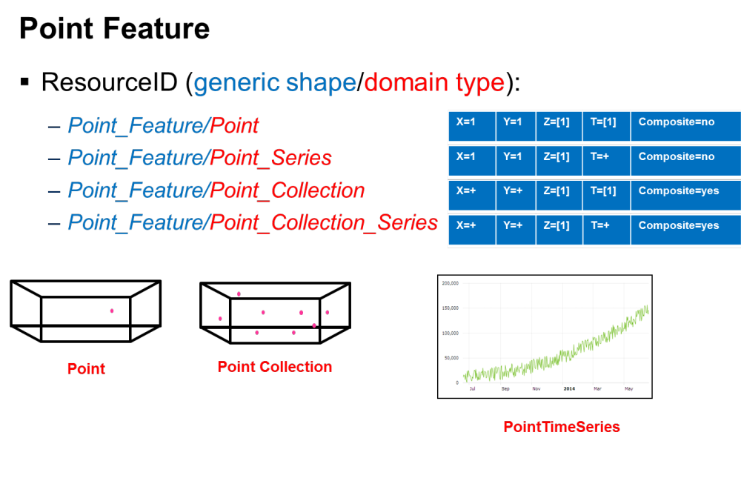

Figure 1 Points
    - Profiles
.
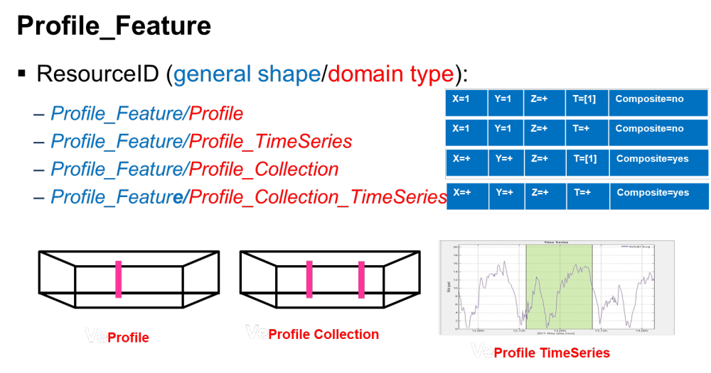
Figure 2 Profiles
    - Grids
.
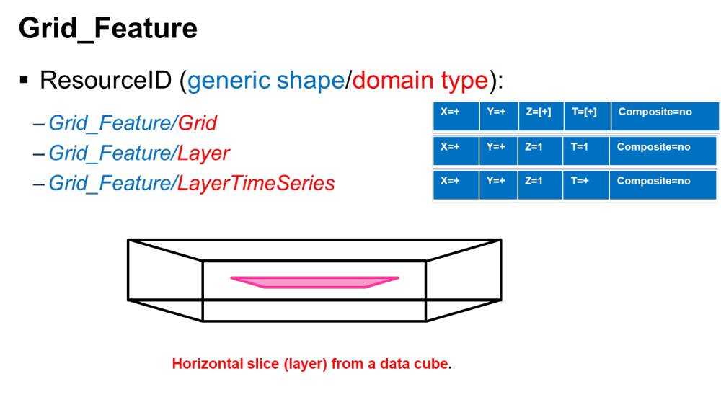
Figure 3 Grid
    - Sections
Figure 4 Cross Section
.
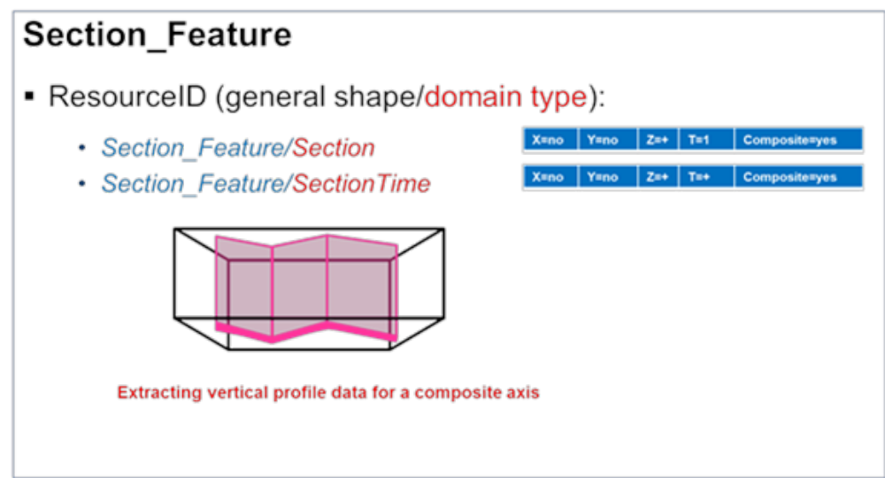

    - Polygon
.
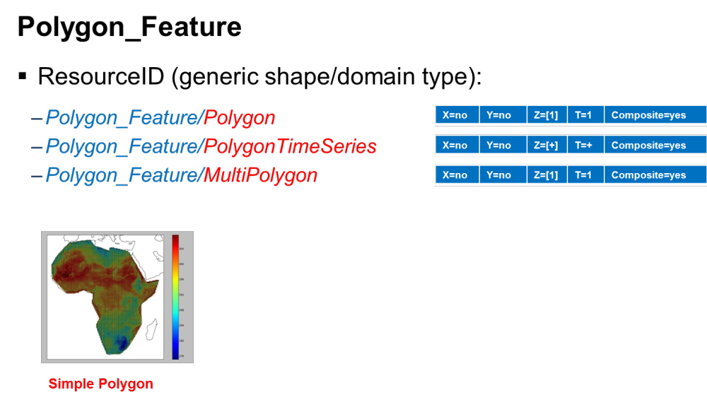
Figure 5 Polygon
    - Trajectory
.
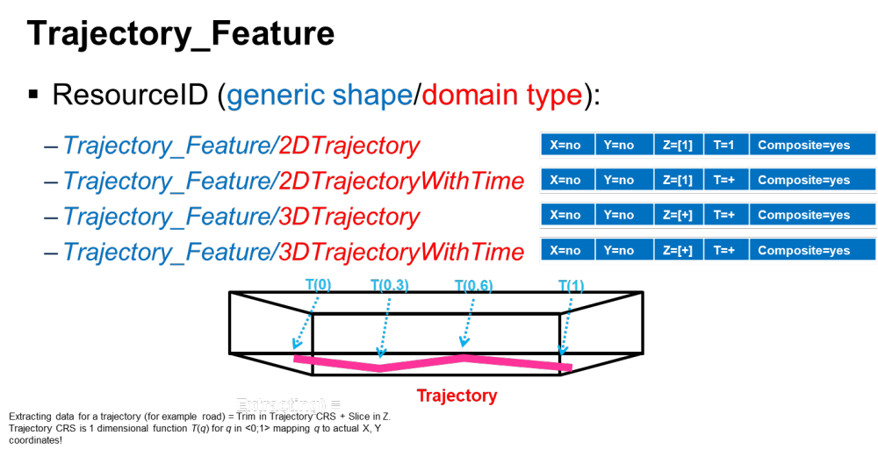
Figure 6 Trajectory

  - Methods
In order to create the new “Domain Types” from the source “Domain” a set of methods are applied to each axis. The database will need to support the following methods are described in detail in the following sections.
- sub-setting
- sampling
- Enumeration/List: Denotes specific area(s) / time(s) on the corresponding axes.
- Composite axis
These methods do not apply to all “Domain Types” and in some cases, there will be a mixture, i.e. one axes may use one method and another axis a different method . The MetOcean profile of WCS2.1 supports these methods. The “enumeration method” is in fact two methods one for a list of points and another for a singular point. The reason for this will become clear in the examples. For “Domain types” trajectories, sections and polygons, then a composite aaxis is used to define the “base line” axis.

    - Sub-setting
A bounding box is define to act as a container for all date within it. The bounding box maybe multi-dimensional with a minimum of two .

Horizontal
- HorizontalSubset (HSUB)
    - The HorizontalBoundingBox
        - Lower left corner, coordinate axis 1
        - Lower left corner, coordinate axis 2
        - Upper right corner, coordinate axis 1
        - Upper right corner, coordinate axis 2
Example WCS2.1 GetCoverage Code snippet
<wcs:DimensionTrim>
<wcs:Dimension>Lat</wcs:Dimension>
<wcs:TrimLow>50.0</wcs:TrimLow>
<wcs:TrimHigh>60.0</wcs:TrimHigh>
</wcs:DimensionTrim>
<wcs:DimensionTrim>
<wcs:Dimension>Lon</wcs:Dimension>
<wcs:TrimLow>-10.0</wcs:TrimLow>
<wcs:TrimHigh>10.0</wcs:TrimHigh>
</wcs:DimensionTrim>

Vertical
- VerticalSubset (VSUB)
    - The VerticalBoundingBox:
        - Lower level, coordinate axis 1
        - Upper level, coordinate axis 2
Example WCS2.1 GetCoverage Code snippet
<wcs:DimensionTrim>
<wcs:Dimension>Isobaric Surface</wcs:Dimension>
<wcs:TrimLow>85000.0</wcs:TrimLow>
<wcs:TrimHigh>20000.0</wcs:TrimHigh>
</wcs:DimensionTrim>
Time
- TimeSubset (TSUB)
    - The TimeBoundingBox
        - Start Time
        - End Time

Example WCS2.1 GetCoverage Code snippet
<wcs:DimensionTrim>
<wcs:Dimension>ValidityTime</wcs:Dimension>
<wcs:TrimLow>2017-05-15T00:00:00Z</wcs:TrimLow>
<wcs:TrimHigh>2017-05-15T12:00:00Z</wcs:TrimHigh>
</wcs:DimensionTrim>

    - Sampling
Similar to the subset (i.e. it has a bounding box), but the axes are sampled, thus a Start point, End point, and interval are required for each axis.

Horizontal
- HorizontalSampling (HSAMP)
    - The Horizontal Sampling parameters
        - Lower left corner, coordinate axis 1
        - Lower left corner, coordinate axis 2
        - Upper right corner, coordinate axis 1
        - Upper right corner, coordinate axis 2
        - Coordinate axis 1 interval
        - Coordinate axis 2 interval
Example WCS2.1 GetCoverage Code snippet
<wcs:Extension>
<int:Interpolation>
<int:globalInterpolation>http://interpolation/OGC/1/linear</int:globalInterpolation>
<int:InterpolationPerAxis>
<int:axis>Lat/</int:axis> <int:interpolationMethod>http://www.opengis.net/def/interpolation/linear/</int:interpolationMethod>
</int:InterpolationPerAxis>
<int:InterpolationPerAxis>
<int:axis>Lon/</int:axis>
<int:interpolationMethod>http://interpolation/OGC/1/cubic</int:interpolationMethod>
</int:InterpolationPerAxis>
</int:Interpolation>
<scal:Scaling>
<scal:ScaleToSize>
<scal:TargetAxisSize>
<scal:axis>Lat</scal:axis>
<scal:targetSize>11</scal:targetSize>
</scal:TargetAxisSize>
<scal:TargetAxisSize>
<scal:axis>Lon</scal:axis>
<scal:targetSize>11</scal:targetSize>
</scal:TargetAxisSize>
</scal:ScaleToSize>
</scal:Scaling>
</wcs:Extension>
<wcs:DimensionTrim>
<wcs:Dimension>Lat</wcs:Dimension>
<wcs:TrimLow>50.0</wcs:TrimLow>
<wcs:TrimHigh>60.0</wcs:TrimHigh>
</wcs:DimensionTrim>
<wcs:DimensionTrim>
<wcs:Dimension>Lon</wcs:Dimension>
<wcs:TrimLow>-10.0</wcs:TrimLow>
<wcs:TrimHigh>10.0</wcs:TrimHigh>
</wcs:DimensionTrim>
Note that in this case that there will be 11 points in the latitude and longitude axis.

- VerticalSampling (VSAMP)
    - The VerticalSamplingParameters:
        - First lower level coordinate
        - Second upper level coordinate
        - Coordinate axis 1 interval
Example WCS2.1 GetCoverage Code snippet
<wcs:Extension>
<int:Interpolation>
<int:globalInterpolation>interpolation/OGC/1/Barycentric</int:globalInterpolation>
<int:InterpolationPerAxis>
<int:axis>Isobaric Surface</int:axis>
<int:interpolationMethod>/http://interpolation/OGC/1/cubic /</int:interpolationMethod>
</int:InterpolationPerAxis>
</int:Interpolation>
<scal:Scaling>
<scal:ScaleToSize>
<scal:TargetAxisSize>
<scal:axis>Isobaric Surface</scal:axis>
<scal:targetSize>13</scal:targetSize>
</scal:TargetAxisSize>
</scal:ScaleToSize>
</scal:Scaling>
</wcs:Extension>
<wcs:DimensionTrim>
<wcs:Dimension>Isobaric Surface</wcs:Dimension>
<wcs:TrimLow>100000.0</wcs:TrimLow>
<wcs:TrimHigh>20000.0</wcs:TrimHigh>
</wcs:DimensionTrim>

Note that in this case that there will be 13 points in the vertical.

- TimeSampling (TSAMP)
- The TimeSamplingParameters
- Start Time
- End Time
- Time Interval
Example WCS2.1 GetCoverage Code snippet

<wcs:Extension>
<int:Interpolation>
<int:globalInterpolation>http://interpolation/OGC/1/linear</int:globalInterpolation>
<int:InterpolationPerAxis>
<int:axis>Time</int:axis>
<int:interpolationMethod>
http://interpolation/OGC/1/lNearest_Neighbour/</int:interpolationMethod>
</int:InterpolationPerAxis>
</int:Interpolation>
<scal:Scaling>
<scal:ScaleToSize>
<scal:TargetAxisSize>
<scal:axis>Isobaric Surface</scal:axis>
<scal:targetSize>13</scal:targetSize>
</scal:TargetAxisSize>
</scal:ScaleToSize>
</scal:Scaling>
</wcs:Extension>

<wcs:DimensionTrim>
<wcs:Dimension>ValidityTime</wcs:Dimension>
<wcs:TrimLow>2017-05-15T00:00:00Z</wcs:TrimLow>
<wcs:TrimHigh>2017-05-15T12:00:00Z</wcs:TrimHigh>
</wcs:DimensionTrim>
Note that in this case that there will be 13 points in the time axis.

    - Point
The values for each axis are a set of tuples separated using a “\”. For the vertical axis, a uom (unit of measure) parameter is used. The horizontal points are in lat/lon. Note the use of plurals.

- HorizontalPoint (HP)
    - Horizontal Point Parameter:
- &Point=X,Y
Example WCS2.1 GetCoverage Code snippet
<wcs:DimensionSlice>
<wcs:Dimension>Lat</wcs:Dimension>
<wcs:SlicePoint>50.0</wcs:SlicePoint>
</wcs:DimensionSlice>
<wcs:DimensionSlice>
<wcs:Dimension>Lon</wcs:Dimension>
<wcs:SlicePoint>10.0</wcs:SlicePoint>
</wcs:DimensionSlice>

- VerticalPoint (VP)
    - Horizontal Point Parameter
        - Level=Value (in the vertical Coordinate)
Example WCS2.1 GetCoverage Code snippet
<wcs:DimensionSlice>
<wcs:Dimension>Isobaric Surface</wcs:Dimension>
<wcs:SlicePoint>500.0</wcs:SlicePoint>

- TimePoint (TP)
    - Horizontal Point Parameter
        - &Time=ISO8601
Example WCS2.1GetCoverage Code snippet
<wcs:DimensionSlice>
<wcs:Dimension>Time</wcs:Dimension>
<wcs:SlicePoint>2017-05-15T00:00:00Z </wcs:SlicePoint>

    - Points
The values for each axis are a set of tuples separated using a “\”. For the vertical axis, a uom (unit of measure) parameter is used. The horizontal points are in lat/lon. Note the use of plurals. &Points=50.0,10.0,60.0.15.0,70.0,20.0

- HorizontalPoints (HPS)
- Horizontal Points Parameter:
  - Points= 50.0,10.0,60.0.15.0,70.0,20.0
Example WCS2.1 GetCoverage Code snippet
<wcs:DimensionSlice>
<wcs:Dimension>Lat</wcs:Dimension>
<wcs:SlicePoint>50.0,60.0,70.0</wcs:SlicePoint>
</wcs:DimensionSlice>
<wcs:DimensionSlice>
<wcs:Dimension>Lon</wcs:Dimension>
<wcs:SlicePoint>10.0,15.0,20.0</wcs:SlicePoint>
</wcs:DimensionSlice>

- VerticalPoints (VPS)
    - Vertical Points Parameters
  - Vertical Points= 50000,30000,25000,200000 (Units Pa)
Example WCS2.1 GetCoverage Code snippet
<wcs:DimensionSlice>
<wcs:Dimension> Isobaric Surface</wcs:Dimension>
<wcs:SlicePoint>50000.0,30000,25000,20000</wcs:SlicePoint>TimePoints

- TimePoints (TPS)
    - Time Points Parameter
    - Time Points= 2017-05-15T00:00:00Z, 2017-05-15T12:00:00Z Example WCS2.1 GetCoverage Code snippet
<wcs:DimensionSlice>
<wcs:Dimension>Time</wcs:Dimension>
<wcs:SlicePoint>2017-05-15T00:00:00Z, 2017-05-15T12:00:00Z </wcs:SlicePoint>
    - Polygons

- Simple Polygon Description (POLY)
    - The simple polygon description simply describes the polygon in x,y.
Example WCS2.1 GetPolygon Code snippet
<metoceanpolygon:polygonDescription>
<metoceanpolygon:PolygonDescription>
<metoceanpolygon:polygonGeometry>
<metoceanpolygon:PolygonRing gml:id="ID000">
<gml:Polygon gml:id="Model_Boundary-Geometry"
uomLabels="deg deg" axisLabels="lat Lon"
srsDimension="2"
srsName="http://www.opengis.net/def/crs/EPSG/0/4326">
<gml:exterior>
<gml:LinearRing>
<gml:posList> -90.0 -180.0 90.0 -180.0 90.0 180.0
-90.0 180.0 -90.0 -180.0 </gml:posList>
</gml:LinearRing>
</gml:exterior>
</gml:Polygon>
</metoceanpolygon:PolygonRing>
</metoceanpolygon:polygonGeometry>
</metoceanpolygon:PolygonDescription>
</metoceanpolygon:polygonDescription>

- PolygonDescription Time Series (POLYTSERIES)
    - The polygon description in x,y includes a series of times.
Example WCS2.1 GetPolygon Code snippet
<metoceanpolygon:polygonDescription>
<metoceanpolygon:PolygonDescription>
<metoceanpolygon:polygonGeometry>
<metoceanpolygon:PolygonRing gml:id="ID000">
<gml:Polygon gml:id="Model_Boundary-Geometry"
uomLabels="deg" axisLabels="lat Lon"
srsDimension="2"
srsName="http://www.opengis.net/def/crs/EPSG/0/4326">
<gml:exterior>
<gml:LinearRing>
<gml:posList> -90.0 -180.0 90.0 -180.0 90.0 180.0
-90.0 180.0 -90.0 -180.0 </gml:posList>
</gml:LinearRing>
</gml:exterior>
</gml:Polygon>
</metoceanpolygon:PolygonRing>
</metoceanpolygon:polygonGeometry>
<metoceanpolygon:verticaTemporalDescription>
<metoceanpolygon:VerticalTemporalDescription>
<metoceanpolygon:subsetByTrim>
<metoceanpolygon:SubsetByTrim>
<metoceanpolygon:dimensionTrim>
<metoceanpolygon:DimensionTrim uomLabel="ISO8601">
<metoceanpolygon:dimension>Time</metoceanpolygon:dimension>
<metoceanpolygon:trimLow>2017-05-14T00:00:00Z</metoceanpolygon:trimLow>
<metoceanpolygon:trimHigh>2017-05-15T00:00:00Z</metoceanpolygon:trimHigh>
</metoceanpolygon:DimensionTrim>
</metoceanpolygon:dimensionTrim>
</metoceanpolygon:SubsetByTrim>
</metoceanpolygon:subsetByTrim>
</metoceanpolygon:VerticalTemporalDescription>
</metoceanpolygon:verticaTemporalDescription>
</metoceanpolygon:PolygonDescription>
</metoceanpolygon:polygonDescription>

- PolygonDescription Vertical Levels (POLYLEVELS)
    - The polygon in x,y is extracted for a series of vertical levels
Example WCS2.1 GetPolygon Code snippet
<metoceanpolygon:polygonDescription>
<metoceanpolygon:PolygonDescription>
<metoceanpolygon:polygonGeometry>
<metoceanpolygon:PolygonRing gml:id="ID000">
<gml:Polygon gml:id="Model_Boundary-Geometry"
uomLabels="deg deg" axisLabels="lat Lon"
srsDimension="2"
srsName="http://www.opengis.net/def/crs/EPSG/0/4326">
<gml:exterior>
<gml:LinearRing>
<gml:posList> -90.0 -180.0 90.0 -180.0 90.0 180.0
-90.0 180.0 -90.0 -180.0 </gml:posList>
</gml:LinearRing>
</gml:exterior>
</gml:Polygon>
</metoceanpolygon:PolygonRing>
</metoceanpolygon:polygonGeometry>
<metoceanpolygon:verticalTemporalDescription>
<metoceanpolygon:VerticalTemporalDescription>
<metoceanpolygon:subsetByTrim>
<metoceanpolygon:SubsetByTrim>
<metoceanpolygon:dimensionTrim>
<metoceanpolygon:DimensionTrim uomLabel="hPA">
<metoceanpolygon:dimension>Pressure</metoceanpolygon:dimension>
<metoceanpolygon:trimLow>200.0</metoceanpolygon:trimLow>
<metoceanpolygon:trimHigh>1000.0</metoceanpolygon:trimHigh>
</metoceanpolygon:DimensionTrim>
</metoceanpolygon:dimensionTrim>
</metoceanpolygon:SubsetByTrim>
</metoceanpolygon:subsetByTrim>
</metoceanpolygon:VerticalTemporalDescription>
</metoceanpolygon:verticaTemporalDescription>
</metoceanpolygon:PolygonDescription>
</metoceanpolygon:polygonDescription>

- PolygonDescription Vertical Levels (POLYLEVELSTSERIES)
    - The polygon in x,y is extracted for a series of vertical levels and times
Example WCS2.1 GetPolygon Code snippet
<metoceanpolygon:polygonDescription>
<metoceanpolygon:PolygonDescription>
<metoceanpolygon:polygonGeometry>
<metoceanpolygon:PolygonRing gml:id="ID000">
<gml:Polygon gml:id="Model_Boundary-Geometry"
uomLabels="deg deg" axisLabels="lat Lon"
srsDimension="2"
srsName="http://www.opengis.net/def/crs/EPSG/0/4326">
<gml:exterior>
<gml:LinearRing>
<gml:posList> -90.0 -180.0 90.0 -180.0 90.0 180.0
-90.0 180.0 -90.0 -180.0 </gml:posList>
</gml:LinearRing>
</gml:exterior>
</gml:Polygon>
</metoceanpolygon:PolygonRing>
</metoceanpolygon:polygonGeometry>
<metoceanpolygon:verticalTemporalDescription>
<metoceanpolygon:VerticalTemporalDescription>
<metoceanpolygon:subsetByTrim>
<metoceanpolygon:SubsetByTrim>
<metoceanpolygon:dimensionTrim>
<metoceanpolygon:DimensionTrim uomLabel="hPA">
<metoceanpolygon:dimension>Pressure</metoceanpolygon:dimension>
<metoceanpolygon:trimLow>200.0</metoceanpolygon:trimLow>
<metoceanpolygon:trimHigh>1000.0</metoceanpolygon:trimHigh>
</metoceanpolygon:DimensionTrim>
<metoceanpolygon:DimensionTrim uomLabel="ISO8601">
<metoceanpolygon:dimension>Time</metoceanpolygon:dimension>
<metoceanpolygon:trimLow>2017-05-14T00:00:00Z</metoceanpolygon:trimLow>
<metoceanpolygon:trimHigh>2017-05-15T00:00:00Z</metoceanpolygon:trimHigh>
</metoceanpolygon:DimensionTrim>
</metoceanpolygon:dimensionTrim>
</metoceanpolygon:SubsetByTrim>
</metoceanpolygon:subsetByTrim>
</metoceanpolygon:VerticalTemporalDescription>
</metoceanpolygon:verticaTemporalDescription>
</metoceanpolygon:PolygonDescription>
</metoceanpolygon:polygonDescription>

    - Trajectories and Cross Sections

- Path (spatial only in x,y, and at one time) (PATH)
Example WCS2.1 GetCorridor Code snippet
<metoceancorridor:path>
<metoceancorridor:PathDescription srsName="http://www.opengis.net/def/crs/EPSG/0/4326"
axisLabels="Lat Lon Time Specific_altitude_above_mean_sea_level">
<cis:DisplacementAxisNest axisLabels="Lat Lon Time" uomLabels="deg deg ISO8601">
<cis:P><cis:C>45.0</cis:C><cis:C>5.0</cis:C><cis:C>2015-05-15T00:00:00Z</cis:C></cis:P>
<cis:P><cis:C>46.0</cis:C><cis:C>0.0</cis:C><cis:C>2015-05-15T00:00:00Z</cis:C></cis:P>
<cis:P><cis:C>47.0</cis:C><cis:C>-5.0</cis:C><cis:C>2015-05-15T00:00:00Z</cis:C></cis:P>
<cis:P><cis:C>48.0</cis:C><cis:C>-10.0</cis:C><cis:C>2015-05-15T00:00:00Z</cis:C></cis:P>
<cis:P><cis:C>49.0</cis:C><cis:C>-15.0</cis:C><cis:C>2015-05-15T00:00:00Z</cis:C></cis:P>
<cis:P><cis:C>51.0</cis:C><cis:C>-20.0</cis:C><cis:C>2015-05-15T00:00:00Z</cis:C></cis:P>
<cis:P><cis:C>52.0</cis:C><cis:C>-25.0</cis:C><cis:C>2015-05-15T00:00:00Z</cis:C></cis:P>
</cis:DisplacementAxisNest>
</cis:DisplacementAxisNest>
<cis:GridLimits srsName="http://www.opengis.net/def/crs/OGC/0/Index1D" axisLabels="i">
<cis:IndexAxis axisLabel="i" lowerBound="0" upperBound="6"/>
</cis:GridLimits>
</metoceancorridor:PathDescription>
</metoceancorridor:path>

- Path (spatial in x,y and temporal) (PATHT)
    - A path in x,y for a trajectory (corridor) , for any trajectory coverage with no vertical dependency, but each point has a specific time.
Example WCS2.1 GetCorridor Code snippet
<metoceancorridor:path>
<metoceancorridor:PathDescription srsName="http://www.opengis.net/def/crs-compound?
1=http://www.opengis.net/def/crs/EPSG/0/4326&amp;
2=http://http://www.opengis.net/def/crs/OGC/0/AnsiDate" axisLabels="Lat Lon Time">
<cis:DisplacementAxisNest axisLabels="Lat Lon Time" uomLabels="deg deg ISO8601">
<cis:P><cis:C>45.0</cis:C><cis:C>5.0</cis:C><cis:C>2015-05-15T00:00:00Z</cis:C></cis:P>
<cis:P><cis:C>46.0</cis:C><cis:C>0.0</cis:C><cis:C>2015-05-15T01:00:00Z</cis:C></cis:P>
<cis:P><cis:C>47.0</cis:C><cis:C>-5.0</cis:C><cis:C>2015-05-15T02:00:00Z</cis:C></cis:P>
<cis:P><cis:C>48.0</cis:C><cis:C>-10.0</cis:C><cis:C>2015-05-15T03:00:00Z</cis:C></cis:P>
<cis:P><cis:C>49.0</cis:C><cis:C>-15.0</cis:C><cis:C>2015-05-15T04:00:00Z</cis:C></cis:P>
<cis:P><cis:C>51.0</cis:C><cis:C>-20.0</cis:C><cis:C>2015-05-15T05:00:00Z</cis:C></cis:P>
<cis:P><cis:C>52.0</cis:C><cis:C>-25.0</cis:C><cis:C>2015-05-15T06:00:00Z</cis:C></cis:P>
</cis:DisplacementAxisNest>
<cis:GridLimits srsName="http://www.opengis.net/def/crs/OGC/0/Index1D" axisLabels="i">
<cis:IndexAxis axisLabel="i" lowerBound="0" upperBound="6"/>
</cis:GridLimits>
</metoceancorridor:PathDescription>
</metoceancorridor:path>

- Path (spatial, temporal, and vertical) (PATHTV)
    - The path in x,y has a vertical and temporal component
Example WCS2.1 GetCorridor Code snippet

<metoceancorridor:path>
<metoceancorridor:PathDescription srsName="http://www.opengis.net/def/crs-compound?
1=http://www.opengis.net/def/crs/EPSG/0/4326&amp;
2=http://http://www.opengis.net/def/crs/OGC/0/AnsiDate&amp;
3= http://codes.wmo.int/grib2/codeflag/4.5/_102/Specific_altitude_above_mean_sea_level"
axisLabels="Lat Lon Time Specific_altitude_above_mean_sea_level">
<cis:DisplacementAxisNest axisLabels="Lat Lon Time Specific_altitude_above_mean_sea_level" uomLabels="deg deg ISO8601 ft">
<cis:P><cis:C>45.0</cis:C><cis:C>5.0</cis:C><cis:C>2015-05-15T00:00:00Z</cis:C><cis:C>3600</cis:C></cis:P>
<cis:P><cis:C>46.0</cis:C><cis:C>0.0</cis:C><cis:C>2015-05-15T00:15:00Z</cis:C><cis:C>3500</cis:C></cis:P>
<cis:P><cis:C>47.0</cis:C><cis:C>-5.0</cis:C><cis:C>2015-05-15T00:30:00Z</cis:C><cis:C>3400</cis:C></cis:P>
<cis:P><cis:C>48.0</cis:C><cis:C>-10.0</cis:C><cis:C>2015-05-15T00:45:00Z</cis:C><cis:C>3400</cis:C></cis:P>
<cis:P><cis:C>49.0</cis:C><cis:C>-15.0</cis:C><cis:C>2015-05-15T01:00:00Z</cis:C><cis:C>3200</cis:C></cis:P>
<cis:P><cis:C>51.0</cis:C><cis:C>-20.0</cis:C><cis:C>2015-05-15T01:15:00Z</cis:C><cis:C>3000</cis:C></cis:P>
<cis:P><cis:C>52.0</cis:C><cis:C>-25.0</cis:C><cis:C>2015-05-15T01:30:00Z</cis:C><cis:C>2000</cis:C></cis:P>
</cis:DisplacementAxisNest>
<cis:GridLimits srsName="http://www.opengis.net/def/crs/OGC/0/Index1D" axisLabels="i">
<cis:IndexAxis axisLabel="i" lowerBound="0" upperBound="6"/>
</cis:GridLimits>
</metoceancorridor:PathDescription>
</metoceancorridor:path>

- CrossSectionVerticalSampling (CSVSAMP)
    - The vertical level is sampled to form the vertical cross section
Example WCS2.1 GetCorridor Code snippet
<metoceancorridor:corridorExtent>
<metoceancorridor:CorridorExtent srsName="http://www.opengis.net/def/crs/Corridor_Height"
axisLabels="Corridor_Height" srsDimension="2">
<cis:AxisExtent axisLabel="Corridor_Height" uomLabel="hPa" lowerBound="1000.0"
upperBound="100.0"/>
<scal:Scaling>
<scal:ScaleToSize>
<scal:TargetAxisSize>
<scal:axis>Corridor_Height</scal:axis>
<scal:targetSize>10</scal:targetSize>
</scal:TargetAxisSize>
</scal:ScaleToSize>
</scal:Scaling>
</metoceancorridor:CorridorExtent>
</metoceancorridor:corridorExtent>

- CrossSectionVertSubExtent (CSVSUB)
    - The vertical level is subset to form the vertical cross section
Example WCS2.1 GetCorridor Code snippet
<metoceancorridor:corridorExtent>
<metoceancorridor:CorridorExtent srsName="http://www.opengis.net/def/crs/Corridor_Height"
axisLabels="Corridor_Height" srsDimension="2">
<cis:AxisExtent axisLabel="Corridor_Height" uomLabel="hPa" lowerBound="1000.0"
upperBound="100.0"/>
</metoceancorridor:CorridorExtent>
</metoceancorridor:corridorExtent>

- Test cases
In order to test compliance with the use cases the tests have been grouped, and each domain type will have a number of tests. The WCS2.1 queries are made of components which were defined above and given an abbreviation (e.g. for VerticalPoint: VP). Each of these components consist of a complete example and only the parameter’s values need to change. Each test is numbered per DomainType, and full examples will be given in Section 5.

  - Points

DomainType | Tests | Test Queries
Point_Feature/Point  (z=specific level, t=single time) | - HP/VP/TP | Horizontal: HorizontalPoint  Vertical: Optional VerticalPoint  Time: TimePoint
Point_Feature/PointTimeSeries  (z=specific level, t=time series) | - HP/VP/TPS  - HP/VP/TSUB  - HP/VP/TSAMP | Horizontal: HorizontalPoint  Vertical: Optional VerticalPoint  Time: TimePoints/TimeSubset/ TimeSampling
Point_Feature/Point_Collection  (z=surface, t=single time) | - HPS/VP/TP | Horizontal: HorizontalPoints,  Vertical: Optional VerticalPoint  Time: TimePoint
Point_Feature/Point_Collection_TimeSeries  (z=surface, t=time series w/ times sampled every 6hrs) | - HPS/VP/TPS  - HPS/VP/TPSAMP  - HPS/VP/TPSUB | Horizontal: HorizontalPoints,  Vertical: Optional VerticalPoint  Time: TimePoints/TimeSubset/TimeSampling

Table 1 Point(s) Test Case
  - Profiles

Domain Type | Tests | Test Queries
Profile_Feature/Profile  (z=sampled vertical levels every 100 hPa, t=single time) | - HP/VPS/TP  - HP/VSAMP/TP  - HP/VSUB/TP | HorizontalAxis: Point  Vertical Axis: Value list/Subset/Sample  Time Axis: Single Value
Profile_Feature/Profile_TimeSeries  (z=sampled vertical levels every 100 hPa, t=time series w/ times sampled every 6 hrs) | - HP/VPS/TPS  - HP/VSUB/TPS  - HP/VSAMP/TPS  - HP/VPS/TPSUB  - HP/VSUB/TSUB  - HP/VSAMP/TSUB  - HP/VPS/TSAMP  - HP/VSUB/TSAMP  - HP/VSAMP/TSAMP | HorizontalAxis: Point  Vertical Axis: Value list/Subset/Sample  Time Axis: TimePoints/Subset/Sample
Profile_Feature/Profile_Collection  (z=sampled vertical levels every 100 hPa, t=single time) | - HPS/VPS/TP  - HPS/VSUB/TP  - HPS/VSAMP/TP | HorizontalAxis: Point values  Vertical Axis: Values/Subset/Sample  Time Axis: Single Value
Profile_Feature/Profile_Collection_TimeSeries  (z=listed vertical levels, t=time series) | - HPS/VPS/TPS  - HPS/VSUB/TPS  - HPS/VSAMP/TPS  - HPS/VPS/TPSAMP  - HPS/VSUB/TPSAMP  - HPS/VSAMP/TPSAMP  - HPS/VPS/TPSUB  - HPS/VSUB/TPSUB  - HPS/VSAMP/TPSUB | HorizontalAxis: Point values  Vertical Axis: Value list/Subset/Sample  Time Axis: Value list/Subset/Sample

Table 2 Profile Test Case

  - Grids

Domain Type | Tests | Test Queries
Grid_Feature/Grid  (Extraction on all spatial axes, t=single time) | - HPS/VPS/TP  - HPSAMP/VPS/TP  - HPSUB/VPS/TP  - HPS/VPSAMP/TP  - HPSAMP/VPSAMP/TP  - HPSUB/VPSAMP/TP  - HPS/VPSUB/TP  - HPSAMP/VPSUB/TP  - HPSUB/VPSAMP/TP | HorizontalAxis: Points,Sample,Subset  Vertical Axis: Points, Sample/Subset  Time Axis: Single Value
Grid_Feature/Layer  (z=specific level, t=single time) | - HPS/VP/TP  - HPSAMP/VP/TP  - HPSUB/VP/TP | HorizontalAxis: Points,Sample,Subset  Vertical Axis: Point  Time Axis: Single Time
Grid_Feature/LayerTimeSeries  (z=specific level, t=time series) | - HPS/VP/TPS  - HPSAMP/VP/TPS  - HPSUB/VP/TPS  - HPS/VP/TSUB  - HPSAMP/VP/TSUB  - HPSUB/VP/TSUB  - HPS/VP/TSAMP  - HPSAMP/VP/TSAMP  - HPSUB/VP/TSAMP | HorizontalAxis Points,Sample,Subset  Vertical Axis: Point  Time Axis: Points/Subset/Sample
Grid_Feature/GridTimeSeries  (Extraction on all spatial axes, t=time series) | - HPS/VPS/TPS  - HPSAMP/VPS/TPS  - HPSUB/VPS/TPS  - HPS/VSAMP/TPS  - HPSAMP/VSAMP/TPS  - HPSUB/VSAMP/TPS  - HPS/VSUB/TPS  - HPSAMP/VSUB/TPS  - HPSUB/VSUB/TPS  - HPS/VPS/TSAMP  - HPSAMP/VPS/TSAMP  - HPSUB/VPS/TSAMP  - HPS/VSAMP/TSAMP  - HPSAMP/VSAMP/TSAMP  - HPSUB/VSAMP/TSAMP  - HPS/VSUB/TSAMP  - HPSAMP/VSUB/TSAMP  - HPSUB/VSUB/TSAMP  - HPS/VPS/TSAMP  - HPSAMP/VPS/TSUB  - HPSUB/VPS/TSUB  - HPS/VSAMP/TSUB  - HPSAMP/VSAMP/TSUB  - HPSUB/VSAMP/TSUB  - HPS/VSUB/TSUB  - HPSAMP/VSUB/TSUB  - HPSUB/VSUB/TSUB | HorizontalAxis: Points,Sample,Subset  Vertical Axis: Points, Sample/Subset  Time Axis: Points/Subset/Sample

Table 3 Grid Test Case
  - Sections (Using GetCorridor)
The standard WCS2.1 GetCoverage operation does not extend to composite axis (aka DisplacementAxisNest in the CIS 1.1)

Domain Type | Tests | Test Queries
Section_Feature/Section  (x,y=path, z=sampled/subsetted vertical levels, t=single time) | - PATHT/CVSAMP  - PATHT/CVSUB | Horizontal Path (with time)  Vertical Axis: Sample/Subset  Time Axis: Single Value
Section_Feature/SectionTimeSeries  (x,y=path, z=sampled/subsetted vertical levels, t=time series) | - PATHT/CVSAMP  - PATHT/CVSUB | Horizontal Path (with time)  Vertical Axis: Sample/Subset  Time Axis: Coded in the path

Table 4 Section Test Case

  - Polygons
Domain Type | Tests | Test Queries
Polygon_Feature/Polygon  (polygon shape in x,y, z=subset/sampled vertical levels, t=single time) | - POLY | Horizontal Polygon  Vertical Axis: Sample/Subset  Time Axis: Single Value
Polygon_Feature/PolygonTimeSeries  (polygon shape in x,y, z=subset/sampled vertical levels, t=time series) | - POLYSERIES | Horizontal Polygon (with time)  Vertical Axis: Sample/Subset  Time Axis: Coded in the path
Polygon_Feature/MultiPolygon | - POLYLEVELS

Table 5 Polygons Test Case

  - Trajectory
Domain Type | Tests | Test Queries
Trajectory_Feature/2DTrajectory  (z=optional, t=single time) | - PATHT | Horizontal Path in x,y  Vertical Axis: Not required  Time Axis: Single Value
Trajectory_Feature/2DTrajectoryTime | - PATHT | Horizontal Path (in x,y, with time)  Vertical Axis: Not required  Time Axis: Coded in path
Trajectory_Feature/3DTrajectory | - PATHTV | Horizontal Path in x,y  Vertical Axis: Coded in path  Time Axis: Single Value
Trajectory_Feature/3DTrajectoryTime | - PATHTV | Horizontal Path (in x,y, with time)  Vertical Axis: Coded in path  Time Axis: Coded in the path

Table 6 Trajectory Test Case

